IFG Challenge Year 3

Three week Programme

Week One Girlz Stuff Interest
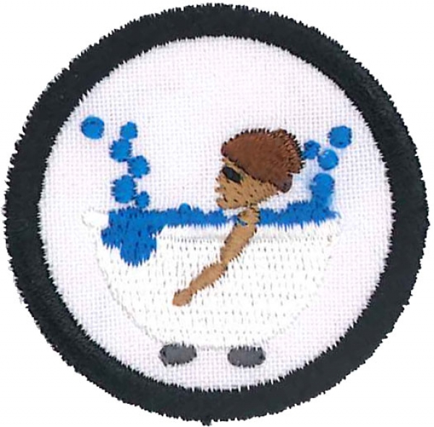

Aim:
The aim of this three week course is to explore what it means to be truly feminine in a world where girls are being bombarded by advertising to conform to a certain image.

Objectives:
- To learn the importance of personal hygiene
- To learn various relaxation methods
- To enjoy a pamper session

First Week: Keep It Clean

Preparation:
Organise a nurse (or similar) who is used to relating to girls of this age to come and take the girls through the finer points of personal hygiene. Some girls may be very sensitive to this subject so the presenter and all leaders present need to be very mindful of this.
In consultation with the presenter, gather up products the presenter will be discussing so girls can see, smell, feel and try some of the items that are available.

Teaching Session:
The presenter would cover such areas as:

Hair – how often to wash – what products are safe to use
Face –– protection from the environment
Skin – moisturizing – sun safe
Break outs – usually on face, back and chest - when to seek medical specialists’ treatment
Hands and nails – when and how to wash hands – nail cleanliness and nail health
Body – include underarms – safe deodorants – body wash or soap?
What to do about hair in places where you don’t want it
Extra hygiene rules during menstruation – pads, tampons
Foot care – smelly feet – looking after toenails
Regular changing of clothing and bedding. Effective laundry procedures
Any other issues / concerns

And encourage girls to ask questions and answer them diplomatically.

Devotions: Psalm 45:8
King James Version (KJV)
⁸All thy garments smell of myrrh, and aloes, and cassia, out of the ivory palaces, whereby they have made thee glad.

Lead a discussion about people who smell “awful” and people who smell “nice”.

During bible times people were not able to bath or shower every day (or at all) nor did they have all the products we have available to us today. Still, many people, especially royalty and those who were better off, tried to smell as nice as they could by using the things that were around at the time.
In this verse we hear about three different herbs and spices -myrrh, aloes and cassia.

Break the group in to three and give each group one of the handouts to discuss and comeback to share with the group what these things actually were. (It would be good to have a leader in each group to direct the discussion). Have a sample of the nearest thing we can get today to these items –

Myrrh
Rosemary has a very pungent, almost medicinal odor to it with woody undertones. Very similar to eucalyptus. It was also used as a substitute for myrrh in incense, since it was much more prevalent and cheaper than myrrh. This incense would be burned as a disinfectant in hospitals.
Use Rosemary Essential Oil of some nice perfume.

Aloes
Aloe Vera is an ingredient in many soothing creams available in health food shops or at the supermarket

Cassia
Is like cinnamon.

You may like to burn some incense during this session.

Devotional closing thought –

2 Corinthians 2:15 New International Version (NIV) says:

For we are to God the pleasing aroma of Christ among those who are being saved and those who are perishing.

(A smell and an aroma mean the same thing).

It is possible for each one of you to be so full of joy that even after you have gone people still feel happy because you were there.

You can demonstrate this by bringing along your best French perfume (or borrow from someone who has some) and select one girl to spray on. Ask her to leave the room and see if the other girls can still smell the perfume.
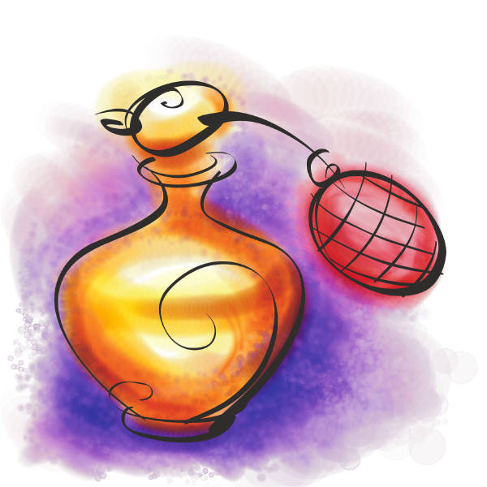

Notices, closing prayer and home time

Frankincense and Myrrh Today
Frankincense and myrrh may not be as popular as they once were, but they're still used today in some ways that you might not expect. They're common ingredients in modern perfumes and cosmetics, continuing a tradition that has lasted thousands of years. Scientists are finding new uses for the substances as well; recent studies suggest that frankincense may be beneficial to sufferers of asthma, rheumatoid arthritis, Crohn's disease, osteoarthritis and collagenous colitis. Researchers have also discovered possible benefits of myrrh in the treatment of gastric ulcers, tumors and parasites.

A Brief History of Frankincense and Myrrh
People in East Africa and the Arabian Peninsula have produced frankincense and myrrh for some 5,000 years [source: Michie]. For much of this time, these aromatic resins were the region's most important commodity, with a trade network that reached across Africa, Asia and Europe. Today, demand for frankincense and myrrh has subsided, but numerous Chinese, Greek, Latin and Sanskrit sources remind us of their past importance.
Frankincense and myrrh were desired for personal, religious and medicinal use. In a time before daily bathing, people would use the sweet smoke from the resins to make themselves smell better. Egyptian women utilized the ash of frankincense for personal use as well, mixing it into their eye shadow. These substances were also widely used in religious ceremonies and burials. According to the Greek writer, Herodotus, the Egyptians used both frankincense and myrrh in the preparation of animal sacrifices and human mummies. Hebrews and Christians incorporated them into their ceremonies in the third century B.C. and fourth century A.D., respectively. Frankincense and myrrh also had medicinal uses. In the Papyrus Ebers of 1500 B.C., priests recommended both resins for the treatment of wounds. Other ailments they were once reported to cure include hemlock poisoning, leprosy, worms, snakebites, diarrhea, plague, scurvy and even baldness!
The high demand for frankincense and myrrh created a booming trade in the Middle East lasting several hundred years. In the first century, around the height of the trade, Pliny the Elder claimed that Arabia produced approximately 1,680 tons (1,524 metric tons) of frankincense and around 448 tons (406 metric tons) of myrrh each year [source: Simpson]. One of the most important trade centers surrounded the Shisr oasis in southern Oman. This outpost exported frankincense across Mesopotamia, India and China from about 300 B.C. to the third century A.D. The ruins of the settlement remain as a UNESCO World Heritage site known as "The Land of Frankincense."
Clearly, frankincense and myrrh were widely available when the Magi visited the baby Jesus around 5 B.C., and would have been considered practical gifts with many uses. The expensive resins were symbolic as well. Frankincense, which was often burned, symbolized prayer rising to the heavens like smoke, while myrrh, which was often used for burials, symbolized death. Accordingly, a mixture of wine and myrrh would be offered to Jesus during his crucifixion.
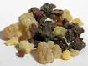

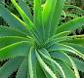

Aloe
From Wikipedia, the free encyclopedia

Aloe species are frequently cultivated as ornamental plants both in gardens and in pots. Many Aloe species are highly decorative and are valued by collectors of succulents. Aloe vera is used both internally and externally on humans, and is claimed to have some medicinal effects, which have been supported by scientific and medical research. The gel in the leaves can be made into a smooth type of cream that can heal burns such as sunburn. They can also be made into types of special soaps.

Historical uses
Historical use of various Aloe species by humans is well documented. Documentation of the clinical effectiveness is available, although relatively limited.^{[3]}
Of the 299 species of Aloe, only a few were used traditionally as a herbal medicine, aloe vera again being the most commonly used version of aloe in herbal medicine. Also included are Aloe perryi (found in northeastern Africa) and Aloe ferox (found in South Africa). The Greeks and Romans used aloe vera to treat wounds. In the Middle Ages, the yellowish liquid found inside the leaves was favored as a purgative.^{[citation needed]} Unprocessed aloe that contains aloin is generally used as a laxative, whereas processed aloe vera juice does not usually contain significant aloin.
Some species, particularly Aloe vera are used in alternative medicine and in the home first aids. Both the translucent inner pulp and the resinous yellow aloin from wounding the Aloe plant are used externally to relieve skin discomforts. As an herbal medicine, aloe vera juice is commonly used internally to relieve digestive discomfort.^{[4][5][6]} Some modern research suggests Aloe vera can significantly slow wound healing compared to normal protocols of treatment.^{[7]} Other reviews of randomised and controlled clinical trials have provided no evidence that Aloe vera has a strong medicinal effect.^{[8][9]}
Today, aloe vera is used both internally and externally on humans. The gel found in the leaves is used for soothing minor burns, wounds, and various skin conditions like eczema and ringworm. The extracted aloe vera juice aloe vera plant is used internally to treat a variety of digestive conditions. The use of this herbal medicine was popularized in the 1950s in many Western countries. The gel's effect is nearly immediate; it also applies a layer over wounds that is said to reduce the chance of any infection.

Cassia
From Wikipedia, the free encyclopedia
Cassia may refer to:
Plants
- Cassia (legume), a tree/shrub genus in the bean family (Fabaceae)
- Cinnamomum aromaticum (cassia or Chinese cinnamon), a cinnamon tree from southern China and Indochina which produces the spice cassia bark
- other species of Cinnamomum, a tree genus in the laurel family (Lauraceae)
- Senna obtusifolia (Chinese Senna or Sicklepod), formerly called Cassia - a source of Cassia gum; seeds are used as an herbal tea in East Asia.
- Senna artemisioides, commonly known as Silver Cassia or Feathery Cassia other species of the Senna (plant) genus of the bean family (Fabaceae)
- locally for introduced Needle Bush (Acacia farnesiana), another Fabaceae

Spices
- Cassia bark, cassia, or Chinese cinnamon - a spice made from the bark of the Cinnamomum aromaticum tree
- Cinnamon, a similar spice for which cassia is often substituted.
Food
- Cassia gum, a food additive made from the seeds of Senna obtusifolia (Cassia obtusifolia, Chinese Senna, or Sicklepod)
- Cassia or Senna tea, East Asian herbal tea made from seeds of Senna obtusifolia (Cassia obtusifolia, Chinese Senna, or Sicklepod

